Instructions for creating an account:

Go to website: https://esneft.ams-sar.com

At the bottom of the page click the option for don’t have an account sign up:

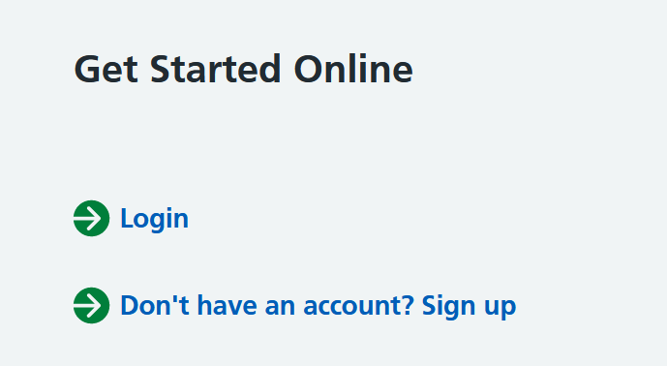
Then enter your email address:

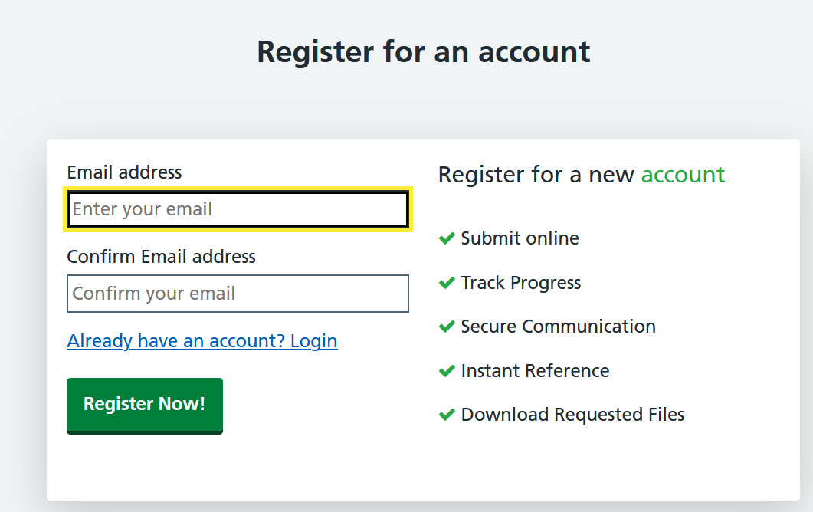

And click Register Now!
You should receive an email like this:
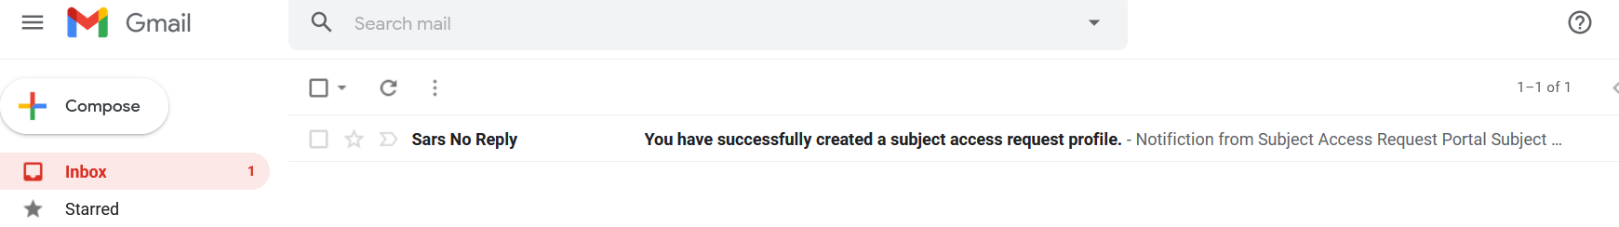

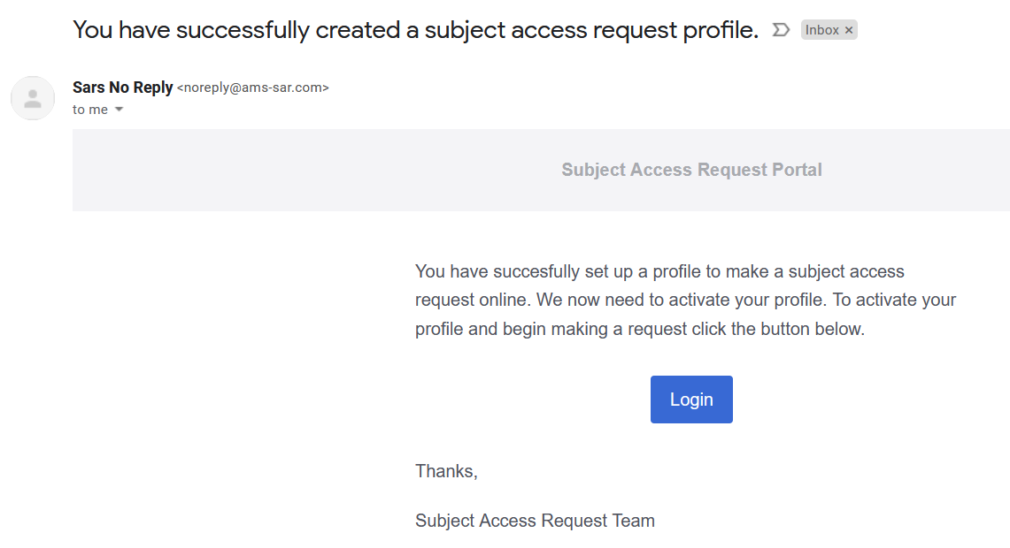

When you click log in you should see this:
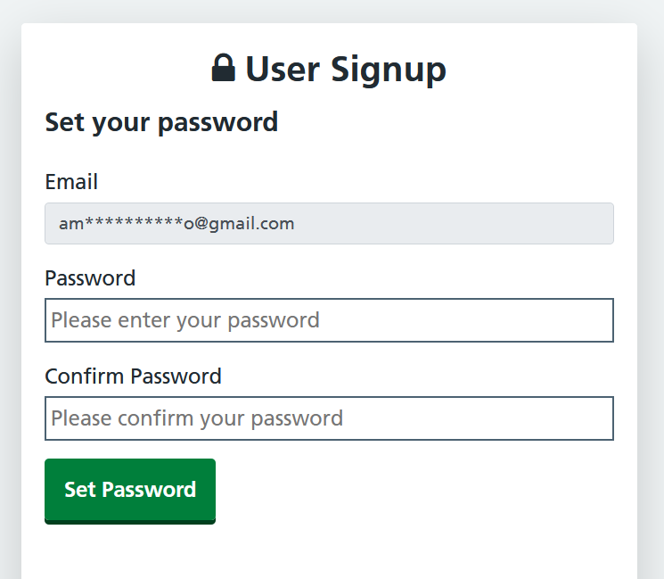

Once you’ve set a password and clicked Set Password you should then be taken to this page:
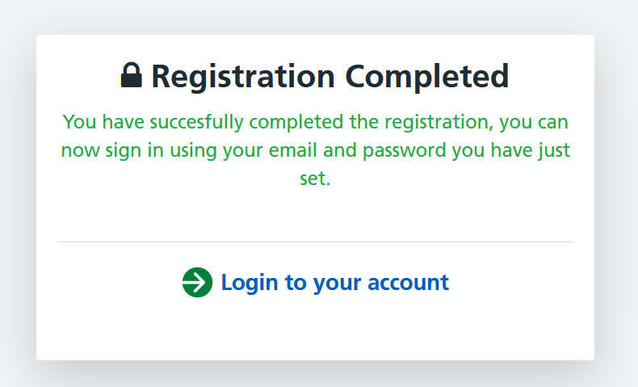

Click Login to your account:
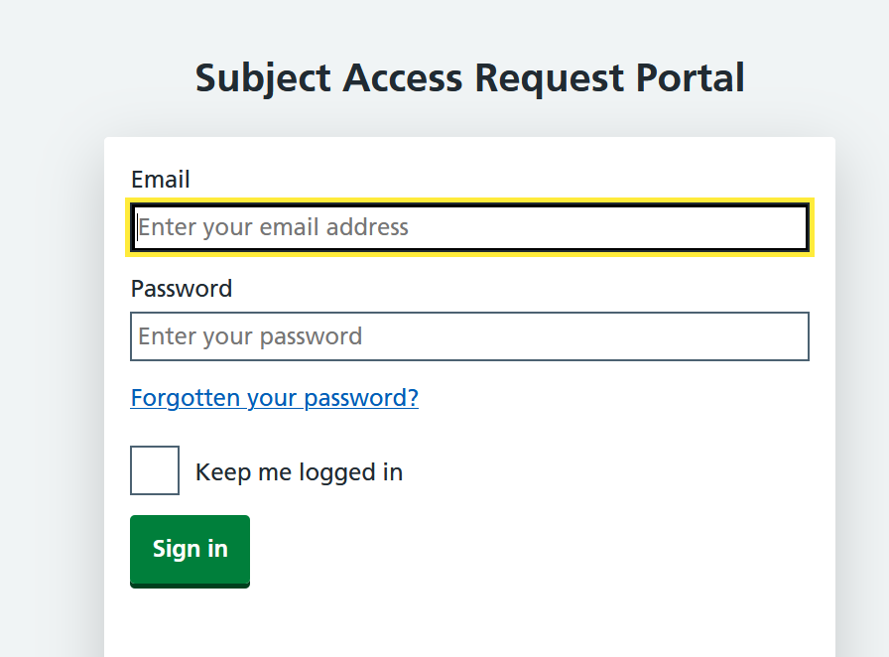

And when you log in you should see this where you can make new requests or manage your existing ones:
